Train Tickets Reservation System

(System Analysis)

1. System Overview
The Train Reservation System is designed to facilitate booking train tickets efficiently. It
allows users to search for available trips, select seats, choose travel class (VIP, First Class,
Second Class, Third Class), and complete payments with different payment methods. The system also enables Roles (administrators, users) administrators to manage trains, trips, and monitor bookings.
The system ensures data consistency, prevents overbooking, and applies pricing rules
based on distance and travel class.

2. Roles
- Customer
- Super Admin
- Admin
- Employee

3. Functional Requirements

User Functionalities
- Register and login using (Username& Password, External Account (Gmail, Facebook))
- Search for trips (From – To Destination – Travel Date, one-way, Round Trip)
- Select Class Level
- View of available trips
- Select travel class
- View of available seats
- Choose a seat
- Book a ticket
- Choose payment Method
- Make a payment
- Cancel booking
- View Profile and Booking history

Admin Functionalities
● Add/Edit/Delete trains
● Define train carriages and classes
● Manage trips (create, update, delete) CRUD Operations
● Set pricing rules
● View bookings and reports

4. Non-Functional Requirements
● Performance
● Scalability
● Security: Authentication باستخدام JWT
● Reliability
● Maintainability: Clean Architecture Easy to Use

5. System Use Cases
Book Ticket Use Case
Role: Passenger

Workflows:
- User logs in
- Enter trip details (From, To, Date, select Trip Class, Ticket Type)
- System displays available trips
- User selects a trip
- User selects class
- System shows available seats
- User selects a seat
- System calculates price
- User makes payment
- booking is confirmed and ticket is generated
- Send Mail To user with all Ticket Details

Alternative Flows:
● Payment failure → booking is not completed
● Seat already booked → user selects another seat
● No seats available → booking rejected or waiting listed

6. Pricing Logic
The system calculates ticket price based on travel distance and carriage class multiplier.
Price = Distance × ClassMultiplier
Class Multipliers:
● VIP = 3
● First Class = 2
● Second Class = 1.5
● Third Class = 1
The system may be extended to support dynamic pricing based on demand and booking
time.

7. Business Rules
● A seat cannot be booked more than once for the same trip
● Booking is not allowed after the trip departure time
● A user cannot book the same trip more than once
● Seat must belong to the selected class
Seat is temporarily locked during booking process
● Total bookings must not exceed train capacity
● Booking is confirmed only after successful payment
● Cancellation is allowed only before departure time
● Price must be calculated based on distance and class
● From and To stations must be different
● Payment must be completed within a limited time window

8. Workflow
1. User logs into the system
2. Searches for a trip (From, To, Date) Filtering
3. System retrieves available trips
4. User selects a trip and class
5. System displays available seats
6. User selects a seat
7. System locks the seat temporarily
8. System validates seat availability
9. System calculates total price
10. User proceeds to payment
11. Payment is processed
12. If payment is successful:
- Booking is confirmed
- Ticket is generated
13. If payment fails:
- Seat lock is released

9. System Architecture Overview
The system follows a layered architecture:
● Presentation Layer (API): Handles incoming HTTP requests
● Application Layer: Implements business use cases
● Domain Layer: Contains core business models and rules
● Infrastructure Layer: Manages database and external integrations

10. Future Enhancements
● Online payment integration (Visa / Wallet)
● Notification system (Email / SMS)
● Seat map visualization
● Waiting list feature
● Dynamic pricing based on demand
● Multi-language support

Initial Data Models

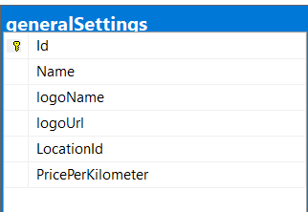 | General Setting for the station
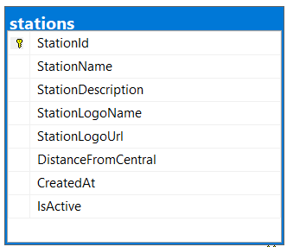 | Trains Stations
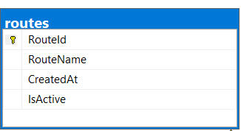 | Train Direction
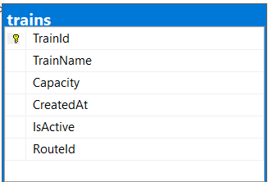 | Trains Info
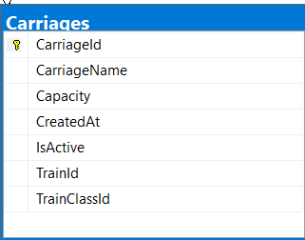 | Carriages of the Train
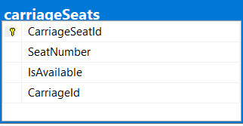 | Carriage Seats
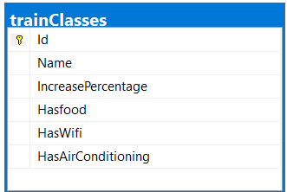 | Carriage Class Level
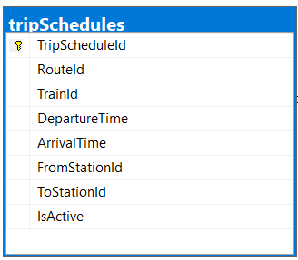 | Trip Schedules and departure Date Time and Arrival Date Time
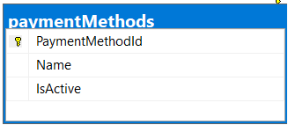 | Payment Methods (Cash, Visa, Insta,)
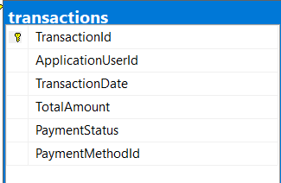 | User Payment Transaction
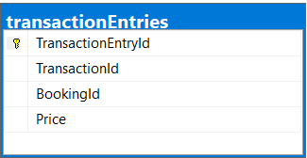 | Transaction Entries Details
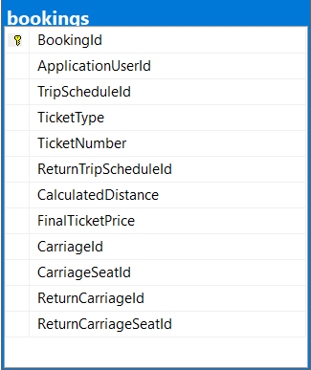 | User booking Table and Ticket details history

SQL Diagram_1

Initial Models Relations - 2
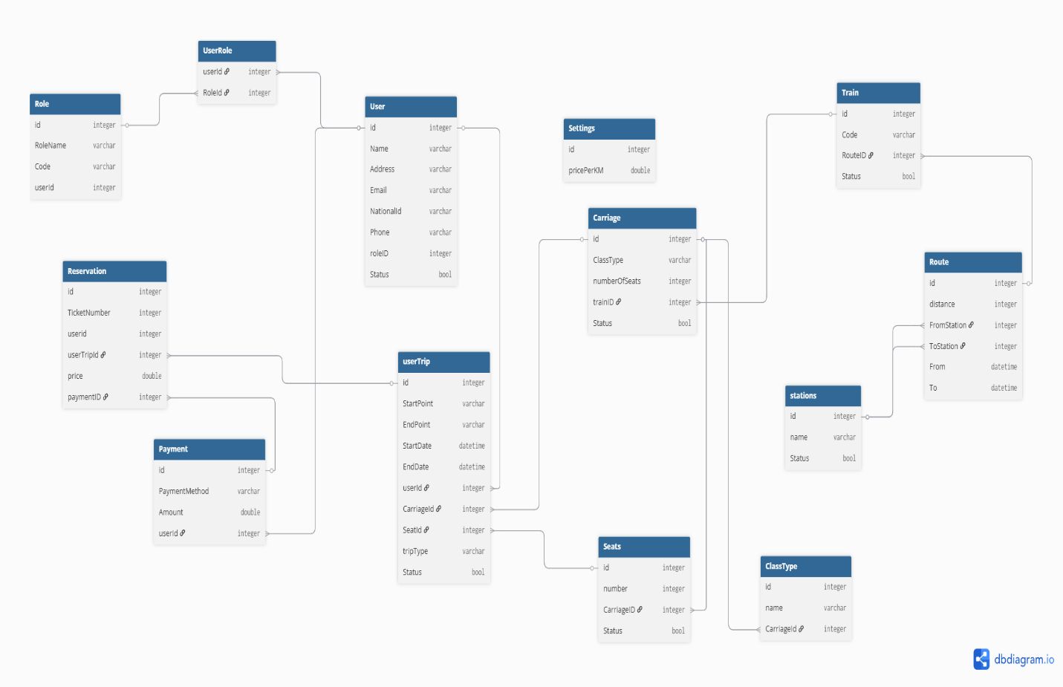

Summary

- GeneralSettings store global system data like logo, location, and base PricePerKilometer used in pricing.

- Stations store all train stations, and each station has details like name, description, and distance from the central station.
- Routes define the train path between stations, and a route is used later to build available scheduled trips.
- Trains store the train information, and each train can be used in many trip schedules.
- Each Train has one or more Carriages.
- Each Carriage belongs to one Train and one Class, such as first class or VIP.
- Carriage Classes store the class features and pricing modifiers, like Wi-Fi, food, air conditioning, and increase percentage.
- Each Carriage has many CarriageSeats.
- TripSchedules represent the actual available trips that users can search for and select by date, departure time, source station, and destination station.
- A TripSchedule connects the selected Route, Train, FromStation, and ToStation for real travel time.
- A user can search for available TripSchedules by date and choose the suitable trip.
- When the user chooses a trip, a Booking is created.
- A Booking belongs to one user and one or more TripSchedule.
- A Booking stores the selected seat and carriage using CarriageId and CarriageSeatId.
- If the ticket is RoundTrip, the booking can also store ReturnTripScheduleId, ReturnCarriageId, and ReturnCarriageSeatId.
- Booking also stores ticket details like TicketType, TicketNumber, CalculatedDistance, and FinalTicketPrice.
- The user selects a payment option from PaymentMethods, such as credit card or InstaPay.
- After payment, a Transaction is created for that user with total amount, date, payment status, and selected payment method.
- Each Transaction can contain one or more TransactionEntries.
- TransactionEntries store the booking details included in that payment, so one transaction can pay for one or multiple bookings.
- This structure lets the user review booking history, payment history, and issue tickets later.
- AspNetRoles and AspNetUserRoles manage authorization, so different users like admin, employee, and customer can have different permissions.

For future reviews

Base Entity
Id
CreatedAt
UpdatedAt
DeletedAt
IsDeleted

User
● status
● Name
● Email

Train
● status
● Name

Carriage
● status
● TrainId
● Class (VIP, First, etc.)
● CarriageNumber
Trip
● status
● TrainId
● FromStation
● ToStation
● Distance
● DepartureTime
Seat
● status
● CarriageId
● SeatNumber
● IsAvailable
● Status (Pending / Confirmed / Cancelled)
Booking
● status
● UserId
● TripId
● SeatId
● TotalPrice
● BookingDate
Ticket
● status
● BookingId
● TicketCode
Payment
●
● BookingId
● Amount
● PaymentMethod (Card / Cash)
● Status
● PaymentDate

7. Relationships
● Train → has many Carriages
● Carriage → has many Seats
● Seat → can be booked in many Bookings (1:N)
● Train → has many Trips
● Trip → has many Bookings
● User → has many Bookings
● Booking → has one Ticket
● Booking → has one Payment

